Some facts that might be interesting and/or helpful for making visuals:

The Republic of Ragusa, or Republic of Dubrovnik, was a maritime republic centered on the city of Dubrovnik, that existed from 1358 to 1808.
The moto of the Republic was: Non bene pro toto libertas venditur auro (latin for: Liberty can not be sold for all the gold of the world).

The government of the Republic was liberal in character and early showed its concern for justice and humanitarian principles. The Republic's flag had the word Libertas (freedom) on it, and the entrance to the Saint Lawrence fortress just outside the Ragusa city walls bears the inscription Non bene pro toto libertas venditur auro (Liberty can not be sold for all the gold of the world). The Republic imposed some restrictions on the slave trade in 1416.

So in brief: Dubrovnik serves as a powerful metaphor for freedom.

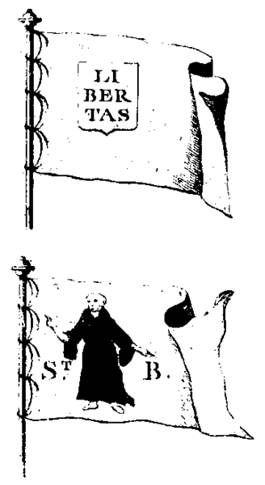

Picture 1. Flags of the Republic of Ragusa in the 18th century, according to the French Encyclopédie.

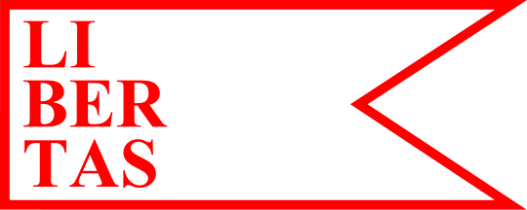

Picture 2. The Libertas flag

Sources:
http://en.wikipedia.org/wiki/Republic_of_Ragusa
http://www.crwflags.com/fotw/flags/hr-du-du.html

DUBROVNIK walls and other symbols

The Dubrovnik walls are one of the most important symbol of Dubrovnik. (they are under UNESCO)
The most notably part is probably the Minčeta tower.
There are also several fortresses .. Revelin fortress, Lovrijenac fortress, Bokar fortress...etc
Orlando column – is important because the the flag of freedom of the Republic of Dubrovnik flew on it for 4 centuries.

http://en.wikipedia.org/wiki/Dubrovnik
http://en.wikipedia.org/wiki/Walls_of_Dubrovnik

According some traditional products .. goldsmiths are the best reference, and it is one of the oldest trades in Dubrovnik.
There are traditional Konavle earrings – even nowadays all ladies in Dubrovnik have a pair. And you can most certainly recognize a women from Dubrovnik by wearing those.

CROATIA

Some general symbols of Croatia that are not connected with specific region are:

- the cravat - originating from 17th-century Croatia. The word "cravat" comes from the Croatian for “croatian” – which is "Hrvat". When used as a symbol it is in red color.
http://academia-cravatica.hr/interesting-facts/

- Glagolitic alphabet – is often used for souvenirs, but I think it's not appliable for Dubrovnik region.
http://en.wikipedia.org/wiki/Glagolitic_script

- Croatian wattle (pleter) – it's often used in coats of arms, important documents.. it could seem too political or too serious
http://en.wikipedia.org/wiki/Croatian_interlace
- Croatian islands – well we sell ourselves to the world as a "land of 1000 islands".
Islands in Dubrovnik archipelago are known as Elaphiti islands.
http://islands.zesoi.fer.hr/meaning/mean7.html
http://www.ncbi.nlm.nih.gov/pmc/articles/PMC2121596/

I definitly wouldn't recommend usage of:
- two (or more) red squares – are commonly used to represent Croatia (for example sports jerseys). There are taken from coat of arms of Croatia, which has a checkerboard made of red and white (silver) fields. Some designers streams in Croatia are forsing to use this as a symbol, but is often just recognized as a symbol for highly formal purposes, except for that is usually used in bad designs.

- dalmatian dogs – well that's just funny, I don't think suse chameleon could look good with black spots, maybe like a little cow :).

TO CONCLUDE:

In my opinion – the Dubrovnik symbols are better to use than general symbols of Croatia. The Libertas flag, and other old Dubrovnik (Ragusa) Republic symbols seems to have more metaphorical and aesthetical value of all.

Even our design studio from Osijek (that is the completely other part of the country) have implement these symbols on a series of their products.
http://lega-lega.com/all-paper-products/libertas-white-spiral-notebook
http://lega-lega.com/all-paper-products/non-bene-red-a5-notebook
http://lega-lega.com/all-paper-products/ragusa-white-a5-notebook

